Marina Hadžiomerović:
Elements of culture in language teaching

Lead-in / Introduction

Do you feel confident teaching British culture?
Do you think there is enough culture in your current textbooks? Is anything missing?
What problems do you encounter?
Are your students interested in cultural elements?
How can you increase their motivation?
Do you use cultural facts for assessment?
Which is easier to grade, language or facts?

CULTURE: the ideas, beliefs, and customs that are shared and accepted by people in a society; activities that are related to art, music, literature etc
TRADITION: a belief, custom, or way of doing something that has existed for a very long time; the way in which things are done in a particular country, group of people etc
CULTURAL: belonging to or connected with a particular society and its way of life
CULTURED: having had a good education so that you are interested in art, music, literature etc
CULTURE SHOCK: the feelings of shock and anxiety that someone has when they visit a foreign country or a new place for the first time

Sequence

- Participants watch the video clip, Unit 1: Introduction to Britain. They are asked to comment on the content, the host Leonie Dodd and the language used.
- Participants work in groups of eight/four. Each member is given a different activity to finish while watching the video clip for the second time. The activities are discussed and feedback is collected from different groups. The structure of the material is explained in detail.
- Unit 7, Pop, video clip is shown and the participants work on the given tasks.
Personal comments are asked for and additional suggestions for classroom work with students is given: a free choice of activities for mixed-ability classes, or a more structurally framed sequence with suggestions based on certain topics in the Way to Go series.
- The video clip with different pop musicians and groups is shown and the
participants are asked to name as many as they can.
5. The participants work on the listening comprehension task about the Spice Girls

Closure

A short summary is given. The final activity offers additional ideas for
expanding the topic of pop music (Oasis: Wonderwall – the verb TO BE).
Additional suggestions: The Police – Englishman...& Lennon/ Ono: Oh my love

A
town, city, island, population, castle, cathedral, countryside, train, bike, capital

Match the words with the pictures:
1 2 3 4 5

6 7 8 9 10

B
tourist, farmer, tractor, coin, stamp, temple, calendar, flag, banknote, university

Match the words with the pictures:

1 2 3 4 5

6 7 8 9 10


C
Find the correct paraphrase for each of the given words:

- a calendar a) a high area of land that is not as high or as
rocky as a mountain
- an island b) a piece of paper money
- a lake c) a large church that is the most important one
in a district
- a cathedral d) a building where people pray and worship a
god or gods
- per cent e) an area of water that is surrounded by land
- a banknote f) a passage under the ground or sea, river, etc.
- a hill g) a town or city by the sea where boats come in
and leave
- a temple h) in or on each hundred
- a port i) an area of land surrounded by water
- a tunnel j) a list that shows the days, weeks and months of
a particular year

D
Give example sentences for the following words:

town, city, capital, island, lake, hill, port, tunnel, cathedral, castle

Explain the words and let your colleagues guess them.

E
Match:
1) Edinburgh ____ universities, bikes
2) York ____ port, The Beatles
3) Liverpool ____ cathedral, narrow streets
4) Stratford-upon-Avon ____ Scotland, castle
5) Cambridge & Oxford ____ birthplace of William Shakespeare

F
Match:
1) banknotes, stamps, coins ____ the British flag
2) temple, clock, calendar ____ Waterloo Station
3) blue, red, white ____ farmland
4) countryside, tractor ____ Stonehenge
5) trains, people ____ the Queen

G
Match:
- Edinburgh a) was once a famous port.
- York b) is the birthplace of William Shakespeare.
- The Beatles c) is famous for its cathedral.
- Liverpool d) is the capital od Scotland.
- Cambridge and Oxford e) come from Liverpool.
- Stratford-upon-Avon f) are also famous for bicycles.

H
Read the sentences and then reconstruct the questions for the given answers.

1. The Giant’s Causeway is in Northern Ireland.
2. Nobody really knows if it is a temple, a clock, or a calendar.
3. The Snowdon National Park is in Wales.
4. 20% of the Welsh population speak Welsh.
5. There are over 800 islands in Britain.
6. The trains from Waterloo Station in London travel through the
Channel Tunnel to Paris, France and to Brussels, Belgium.

________________________________________________________________________

A
Fill in the missing numbers:
49 5 1.5 58 3
1) The population of Britain is over ______ million.
2) England - ______ million
3) Scotland - ______ million
4) Wales - ______ million
5) Northern Ireland - ______ million
Write these numbers in words.

B
Fill in the missing numbers:

1) London has a population of ______ million.
2) The Prime Minister lives at ____ Downing Street.
3) There are ____ national parks in Britain.
4) There are over _____ islands.
5) ____ million foreign tourists visit Britain every year.

C
Write down the information related to the given numbers.

58 ______________________________________________________

49 ______________________________________________________

1.5 ______________________________________________________

3 _______________________________________________________

5 _______________________________________________________

7 _______________________________________________________

D
Write down the information related to the numbers below.

10 _______________________________________________________

75 _______________________________________________________

2 ________________________________________________________

9 ________________________________________________________

24 _______________________________________________________

20 _______________________________________________________

800 ______________________________________________________

E
Listen to Leonie Dodd and order the topics:

____ tourists ____ trains
____ national parks ____ countryside
____ population ____ famous towns and cities
____ parts of the UK ____ islands

F
Circle T (true) or F (false). Correct the false statements.

1) Buckingham Palace is in London. T F
2) The Lake District is in the south of England. T F
3) Snowdon is a river. T F
4) The Giant's Causeway is in Northern Ireland. T F
5) The Prime Minister lives in Wales. T F
G
Circle the correct answer: a, b or c:

- The population of Great Britain is over a) 50 million.
b) 8 million.
c) 58 million.

- The population of England is a) 1.5 million.
b) 49 million.
c) 5 million.

- The population of Scotland is a) 1.5 million.
b) 3 million.
c) 5 million.

- The population of Wales is a) 1.5 million.
b) 3 million.
c) 49 million.

- The population of Northern Ireland is a) 49 million.
b) 3 million.
c) 1.5 million.

H
True or false? Circle the correct option.
1. The population of Great Britain is over 58 million. T F
2. Union Jack, the flag, consists of 4 colours. T F 3. White and red are the colours on the flag that represent
Wales and Northern Ireland. T F
4. The red dragon on the flag represents Wales. T F
5. More people live in Scotland than in Northern Ireland
and Wales. T F
6. 49 million people live in England. T F
7. The Head of the State is Prime Minister. T F
8. Prime Minister lives in Downing Street, 10. T F
9. The Queen's head is on banknotes, stamps and coins. T F
10. The Queen doesn't live in Buckingham Palace because
it's one of the main tourist attractions in London. T F

1. a) Once and now. Do you recognise them? Who is who?

* Sir Elton John
* David Bowie
* Sting (Gordon Matthew Thomas Sumner)
* Boy George (George Alan O'Dowd)
* Victoria Beckham (Posh Spice)

1 2 3 4 5
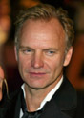

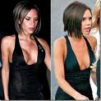
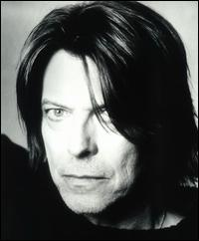


b) Match their current photos to the photos of when they were young:

A B C D E
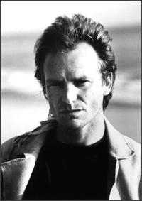
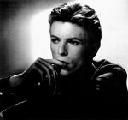


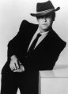

2. a) Match:

1) Annie Lennox a) Welsh
2) Robbie Williams b) Australian
3) Duffy c) Irish
4) Kylie Minogue d) Scottish
5) Michael Jackson e) English
6) Avril Lavigne f) American
7) U2 g) Canadian

b) Who is who?

1 2 3 4 5 6 7

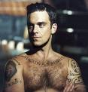
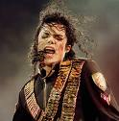
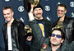

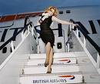
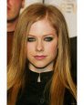

3. Before they started their solo careers, the following singers sang in bands/duos:


- George Michael a) The Police
- Annie Lennox b) Spice Girls
- Sting c) Wham
- Robbie Williams d) Eurythmics
- Geri Halliwell e) Take That

4. Talk about a famous band. Who are the members? Who is the lead singer?
How long have they been performing together? What are their famous songs?

The Rolling Stones (Mick Jagger) Coldplay (Chris Martin)
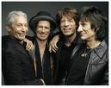
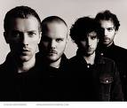

Blur (Damon Albarn) Oasis (Liam Gallagher)
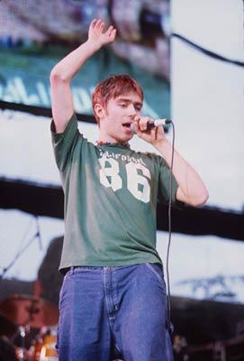
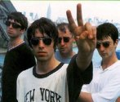
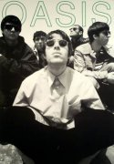
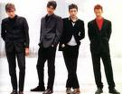

5. What's wrong here?

John Elton, Michael George, Bowie David, Allen Lily, Martin Chris

6. Who sings these songs? Match the songs with the musicians/bands:

1 Yesterday a) Queen
2 Englishman in New York b) Oasis
3 Radio Ga Ga c) Blur
4 Wonderwall d) The Beatles
5 Parklife e) Sting

7. Here are photos of some new female British pop stars. What are their names?
1 2 3 4 5 6 7


8. Watch clip 5 again. Circle the correct letter, a, b or c:
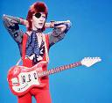
1) David Bowie also acts in a) films and operas.

b) plays and comedies.
c) films and plays.

2) Bowie is still a) rich and famous.
b) popular and handsome.
c) fashionable and hardworking.

3) Elton John is famous for his a) jackets and shirts.
b) clothes and glasses.
c) clothes and shoes.


4) George Michael started his career in a band called a) Blur.
b) Wham.
c) Oasis.

5) In the video of Parklife, there are a) umbrellas.
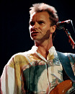
b) bag s. c) chairs.

6) Sting often sings for charity a) firms.
b) organisations.
c) balls.

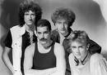
7) Queen were famous for their a) loud fans.
b) live aids.
c) live performances.

8) There are a) five
b) three members of the band Charlie Street.
c) four

LISTENING COMPREHENSION

Fill in:

Charley Street
1. drums | 2. lead singer | 3. lead guitar | 4. bass | 5. backing vocals
Shaun

Their song is called ___________________________________________.

Match:

- Melanie C a) Baby Spice
- Melanie B b) Sporty Spice
- Emma c) Ginger Spice
- Victoria d) Scary Spice
- Geri e) Posh Spice

FOLLOW-UP:

LOVE TIME LIFE EYES LOVER WIND TREES HEART CLOUDS SKY WORLD MIND SORROW DREAMS

LISTENING COMPREHENSION

Spice Girls – How did they get their nicknames?

Answer
They were first named 'Touch' but they decided to change it and one of them thought about Spice because of how different they were from each other. They all dressed differently, acted differently... but there was already a rapper called Spice so they had to change it to Spice Girls.
They got their nicknames thanks to a magazine called TOTP in the UK. They put each girl a nickname that had to do with their personalities. Melanie C always wore trainers and had confortable clothes on so they named her Sporty Spice, Melanie B was always screaming and being loud so they named her Scary Spice, Emma wore pink little dresses and loved candies, and used to talk about her mum all the time so she was Baby Spice, Victoria used to wear the 'little gucci dress' and was very elegant so she was Posh Spice, and Geri was Ginger Spice.

Key: 1b, 2d, 3a, 4e, 5c

Oh My Love - John Lennon/Yoko Ono

Oh my love for the first time in my life
My eyes are wide open
Oh my lover for the first time in my life
My eyes can see

I see the wind, oh I see the trees
Everything is clear in my heart
I see the clouds, oh I see the sky
Everything is clear in our world

Oh my love for the first time in my life
My mind is wide open
Oh my lover for the first time in my life
My mind can feel

I feel sorrow, oh, I feel dreams
Everything is clear in my heart
I feel life, oh, I feel love
Everything is clear in our world

Match:
- Melanie C a) Baby Spice
- Melanie B b) Sporty Spice
- Emma c) Ginger Spice
- Victoria d) Scary Spice
- Geri e) Posh Spice

Match:
- Melanie C a) Baby Spice
- Melanie B b) Sporty Spice
- Emma c) Ginger Spice
- Victoria d) Scary Spice
- Geri e) Posh Spice

Match:
- Melanie C a) Baby Spice
- Melanie B b) Sporty Spice
- Emma c) Ginger Spice
- Victoria d) Scary Spice
- Geri e) Posh Spice

Match:
- Melanie C a) Baby Spice
- Melanie B b) Sporty Spice
- Emma c) Ginger Spice
- Victoria d) Scary Spice
- Geri e) Posh Spice

Match:
- Melanie C a) Baby Spice
- Melanie B b) Sporty Spice
- Emma c) Ginger Spice
- Victoria d) Scary Spice
- Geri e) Posh Spice

Match:
- Melanie C a) Baby Spice
- Melanie B b) Sporty Spice
- Emma c) Ginger Spice
- Victoria d) Scary Spice
- Geri e) Posh Spice
Match:
- Melanie C a) Baby Spice
- Melanie B b) Sporty Spice
- Emma c) Ginger Spice
- Victoria d) Scary Spice
- Geri e) Posh Spice

