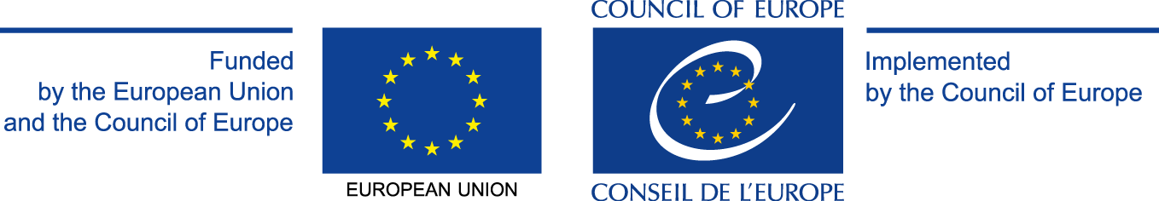

Pilot Project Scheme on Human Rights and Democracy in Action
Project: Travel Pass to Democracy, Supporting Teachers in Preparing Students for Active Citizenship
Trening u Hrvatskoj / Training day in Croatia
Zagreb, 24. rujna 2013./September 24th 2013
Agencija za odgoj i obrazovanje/Education and Teacher Training Agency at the building of the Ministry of Science, Education and Sports
Donje Svetice 38, Zagreb

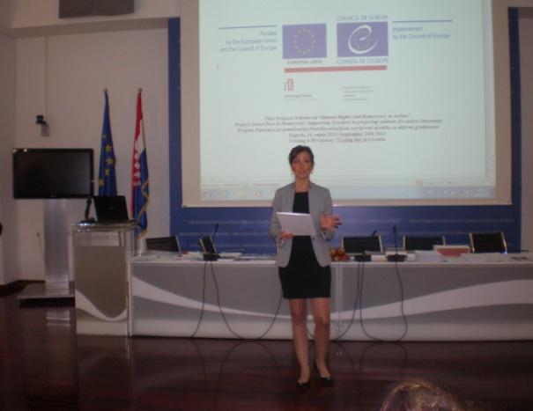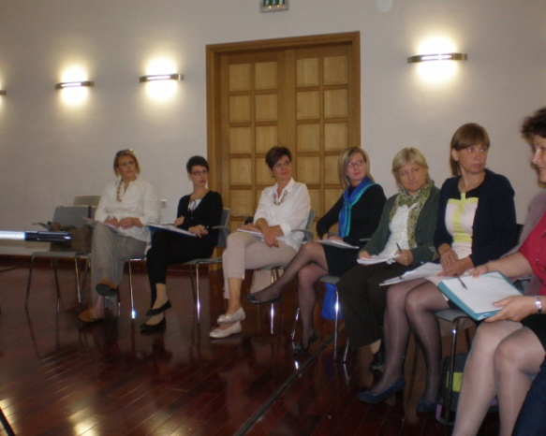

Participants: 32 persons
Croatian team: organisers and lecturers = 3
Teachers = 17, representatives of NGOs = 3, the representative of the Ministry of Science, Education and Sports =1, the representative of media = 1, the representative of Citizens Service of the Croatian Parliament = 1
Observers: Hungary = 1, Romania = 1, Montenegro = 1
Filmmakers = 3 persons

Training day objectives
The objectives of the common module:
- to develop the ability to self-reflect and to initiate change
- to develop strategies to involve students, to address the needs of students and to develop abilities to mobilise knowledge and personal experiences in building new solutions

The objectives of the national module. The participants will:
- get acquainted with the structure of Croatian Citizenship Education Curriculum and with the methodology of planning the outcomes-based instruction
- get acquainted with the examples of good practice in the planning of the outcomes-based instruction for Croatian Citizenship Education Curriculum
- exercise the planning of the outcomes for Croatian Citizenship Education Curriculum
- reflect about the possibilities of transparent and systematic development of students' citizenship competences through different subjects, extra-curricular activities, research projects in school and local community

Handouts:
Council of Europe Charter on Democratic Citizenship Education and Human Rights Education (CM/Rec (2010.)7)
Detailed description of the activities for Module I
The Declaration of children’s rights
Cards on children's rights (Manual Exploring Children’s Rights, Volume V. Pg 89 – 93)
The four basic principles of the children's rights Convention (Manual Exploring Children’s Rights, Volume V, pg 11)
The Fair Bears Learn About Justice: Foundations of Democracy for elementary school level (Center for Civic Education, California, Education and Teacher Training Agency, Zagreb, 2012)
Detailed description of the activities for Module II
Croatian Citizenship Education Curriculum (Education and Teacher Training Agency, Zagreb, 2012)
Good practice examples which define the outcomes of the citizenship competence as the basis for instruction designing
Support materials for instruction designing based on cross-curricular development of citizenship competence
Useful links and literature for further learning in EDC/HRE

The results of the Training day

This training day provided an opportunity to invite the teachers county coordinators for teacher training in EDC/HRE, to present them the CoE Project activities and materials they can use in the implementation of the new curriculum for citizenship education, to ask colleagues from partner countries on their experience and opinion, to disseminate this information and experience to other teachers on the county level and to gain clearer vision on the importance of the implementation of the citizenship education.

Module 1: Respecting Human Dignity In Schools
The teacher trainer was Ms Vedrana Spajić-Vrkaš, international and national expert in EDC/HRE.
She participated in the planning of the Training day and in a very interactive way facilitated the activities of the first module. The teachers developed better understanding of the new approaches to developing attitudes supporting the human dignity in the classroom and school. They also understood that this is one dimension of the citizenship competence defined in the new curriculum for citizenship education.

Module 2: New approach in EDC/HRE teaching and learning: the outcomes-based crosscurricular instruction
Teacher trainers: Vedrana Spajić-Vrkaš, Zdenka Novak, Nevenka Lončarić Jelačić, Tomislav Ogrinšak
The key elements of the new citizenship curriculum, basic EDC/HRE concepts and new approach to cross-curricular planning and teaching were presented to participants. They learned about the examples of good practice in planning of the outcomes-based instruction for Citizenship Education Curriculum. The examples of good practice were presented by a teacher from a school which participates in pilot project of the introduction and implementation of Croatian Citizenship Education Curriculum.
Since the implementation of the Croatian Citizenship Education Curriculum in Croatian primary and secondary schools, it is one of the goals of the Croatian educational policy that the teachers are trained in the methodology of planning of the outcomes based citizenship instruction.
The planning is done in such a way that they elaborate elements for cross-curricular activities: title, purpose, final aim/outcomes, short description of cross-curricular instruction activities, models of implementation, methods, the evaluation of outcomes, expenses (for projects), engaged persons (teachers, students, local community people, etc.). At the end the groups’ representatives presented their plans.
After that a debate in plenum followed about the results of planning and feedback from the participants and visitors.

Feedback
- Feedback from the visitors:
During the Module 1 and Module 2, the visitors were provided with interpreting and the materials in English.
Our visitors reported that they could follow the course of the training and they were especially pleased with it. Regarding the Module 1 the visitors emphasized that training methodology was the same in all the countries and regarding the Module 2 that every country had their own specific approach.
Regarding the atmosphere, the visitors emphasized that the trainers were very dedicated and that the participants were also very active and wished to learn more.

- Feedback from the participants:
We received 20 feedback sheets. The participants were asked to evaluate the different aspects of the training on a 1 to 5 scale where 1 stood for “not agreeing” and 5 for “fully agreeing”, and yes or no.

How useful was the training?
Average: 4.8

Was the aim of the Module 1 clear for participants?
Average: 4.8

Was the aim of the Module 2 clear for participants?
Average: 4.85

Did the training have an effect on you, e.g. did you come to any new understanding, did it motivate you to deal more with this issue?
100 % → yes
1 with no answer

How well connected were the parts of the training?
Average: 4.7

Did you have enough opportunity to be active during the training?
100 % → yes

How good was the interaction between the trainer and the participants?
Average: 4.7

What were the focal messages that you wish to remember?
Focal messages:
- outcomes as the base for planning in teaching
- need for development of attitudes about human dignity in school
- importance of interactive methods
- education focused on competences
- dignity is peaceful resolution of conflicts
- pupils must be educated as future active members of the community
- without responsibility there is no participation
- responsibility comes after engagement
- responsibility as a precondition for active participation
- teamwork as conditio sine qua non in education
- in line with students and their needs
- it is important to be active and responsible citizen
What topic would you like to have addressed in future trainings?
- Need for better understanding of the curricular concepts and elements
- democratic political culture and rule of law
- cross-curricular planning
- quality of teacher trainings for citizenship education
- implementation and evaluation of Croatian Curriculum for Citizenship Education
- pre-service training of future teachers
- examples of good practice
- human rights and gender equality issue

On the end of Training day teachers and observers expressed high level of satisfaction with their participation and with the implementation of the Project Travel Pass to Democracy. They received certificate of participation.

Zagreb, 31. October 2013.

