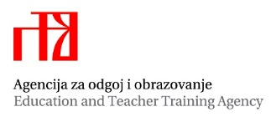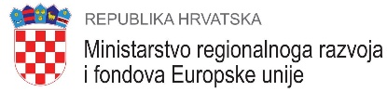

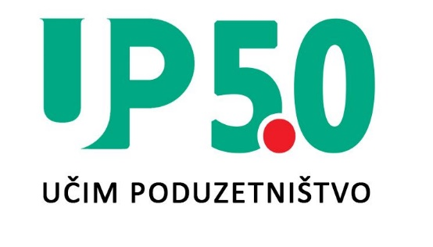
Project “Learning entrepreneurship 5.0”

Partners
Project promoter, the Education and Teacher Training Agency, and Project partners: Vinco Innovation company specialized in innovation and support for entrepreneurs from Norway, the Croatian Association of Student Cooperatives, Vođinci Primary School and "Silvije Strahimir Kranjčević" Primary School in Levanjska Varoš are the institutions that have developed and are implementing the project "Learning entrepreneurship 5.0" .

The project was designed and funded under the EEA/ Financial Mechanism Programme 2014-2021 under the „Local Development and Poverty Reduction” Programme. The project received 173,783.06 EUR of financial support from EEA Financial Mechanism and the Norwegian Financial Mechanism i.e. Iceland, Liechtenstein and Norway within the EEA-grants.

Project description
The project Learning Entrepreneurship 5.0 aims at creating a model for competence development of teachers from Vukovar-Srijem and Osijek-Baranja counties for managing school cooperatives and introducing the cross-curricular topic of entrepreneurship into their practice. In line with teachers’ needs, teacher professional development programme will be designed through cross-sectoral and bilateral cooperation, focusing on teaching learners with special educational needs. Programme will be piloted through training of school cooperatives’ managers. Teachers' competencies related to the promotion and greater visibility of student cooperatives in local community will be strengthened through the organization of student cooperatives’ product fair.

Duration of the project
The implementation of the project started in October 2022 and will last for 18 months, until the end of March 2024.
Aim of a project
The aim of the project is to design an up-to-date professional training program for teachers for the implementation of the cross-curricular topic of entrepreneurship.
In the curriculum of the cross-curricular topic, it is stated that educators, teachers, teachers, professional associates and directors of all educational institutions support the creation of a stimulating environment for the development of entrepreneurial competence. This implies connecting the school with the economy, the labour market and the local / regional community with a special emphasis on mentoring and experiential learning. Entrepreneurship as a value and entrepreneurship as a cross-curricular topic are complementary to all other subjects and cross-curricular topics and are included in all cycles and all subjects and extracurricular activities. Based on the objectives of the curriculum of the cross-curricular topic of entrepreneurship and the low ranking of the cross-curricular topic of entrepreneurship for introduction into teaching through the first phase of the project, the needs and problems of teachers in the implementation of entrepreneurship in the educational process in the two project counties (Vukovar-Srijemska and Osijek- Baranja) will be defined and dressed.

